Satellite Orbits And Tracking

If you’ve ever been to an arena sports event, you may remember the sellers who roved through the stadium, hawking colorful ”program” booklet s that contained the complete rosters of each team, player statistics, photographs and more. You could hear them shouting over the public address system，“Get your program! You can’t tell who the players are without a program!” Strange as it may sound, the sports program has a parallel in the satellite world.

When this book was written, there were no amateur satellites traveling in geostationary orbits. A satellite in a geostationary orbit appears to be stationary in space from our perspective here on Earth. It remains fixed at a single point in the sky 24 hours a day. There is never any doubt about where it is located. You simply aim your antenna at the bird and communicate. Home satellite TV systems are good examples of this concept. The rooftop parabolic dish antennas never move-they don’t need to. Their target is always in the same place.

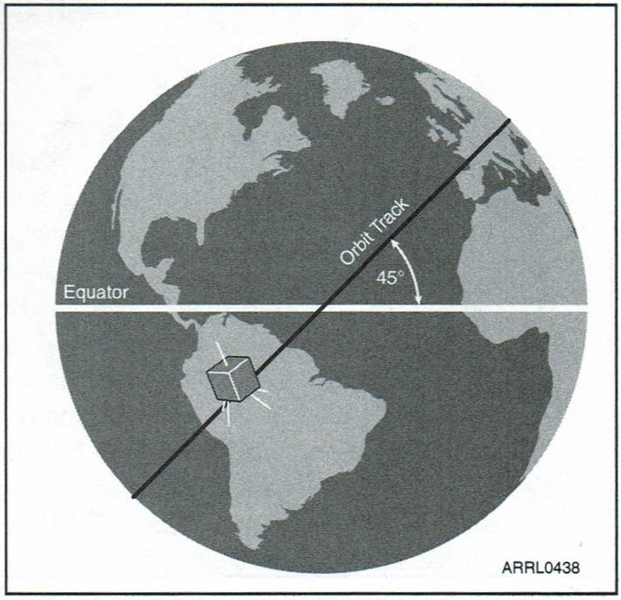Amateur satellites, however, are in orbits close to the Earth, or in oblong, elliptical orbits that take them far into space (beyond where geostationary birds reside) before bringing them back toward Earth for a close, slingshot pass. Since the Earth and the satellites are traveling at different speeds, amateur birds do not remain at fixed points in the sky. Instead, amateur satellites rise above the horizon, soar to a certain altitude (elevation) and then set below the horizon once again. Depending on the nature of the orbit, a satellite may be above the horizon for hours, or only for a few minutes. The satellite may appear several times each day, but each pass will be at a different maximum elevation and will follow a different track across the heavens. To add to the confusion, a satellite may not appear at the same time each day, although it will follow predictable arrival patterns when plotted over days or weeks.

Figure 2.1 - An *inclined* orbit is one that is inclined with respect to the Earth’s equator. In this example, the satellite’s orbit is inclined at 45°to the Equator.

To enjoy an Amateur Radio satellite you need to know where it is, when it will arrive and how it will move across the sky. In other words, to identify these “players，” you do indeed need a “program.” You need a basic understanding of satellite orbits and a program in a different sense of the word: a computer program that will take the information about a satellite’s orbit and turn it into accurate predictions of when it will appear.

Of course, if you really want to gain an appreciation of how a satellite travels in its orbit, tum to Appendix A of this book. That’s where you will find a detailed of discussion of orbital mechanics by Dr Martin Davidoff，K2UBC.

## Types of Orbits

Most active amateur satellites are in various types of Low Earth Orbits (LEOs), although there are satellites planned for future launch that will travel in the elliptical orbits mentioned previously. Let’s take a brief look at several of the most common orbits.

An inclined orbit is one that is inclined with respect to the Earth’s equator. See Figure 2.1. A satellite that is inclined 90° would be orbiting from pole to pole; smaller inclination angles mean that the satellite is spending more time at lower latitudes. The International Space Station, for example, travels in an orbit that is inclined about 50° to the equator. Satellites that move in these orbits frequently fall into the Earth’s shadow (eclipse), so they must rely on battery systems to provide power when the solar panels are not illuminated. Depending on the inclination angle, some locations on the Earth will never have good access because the satellites will rarely rise above their local horizons. This was true, for example, in the days when the US Space Shuttles carried Amateur Radio operators.

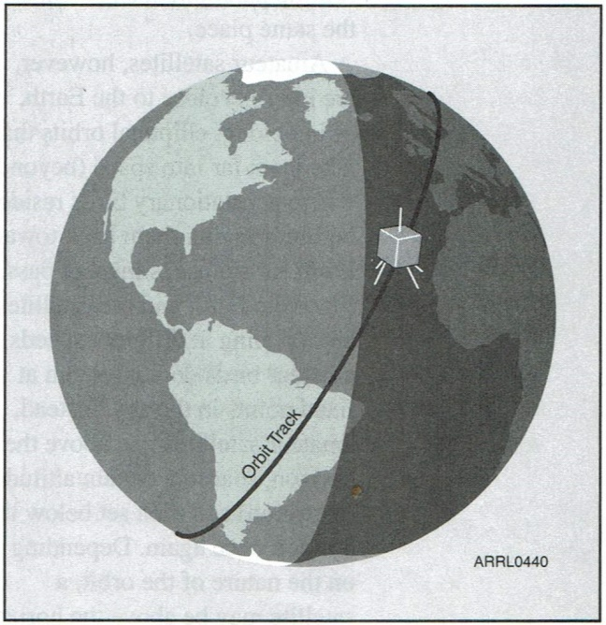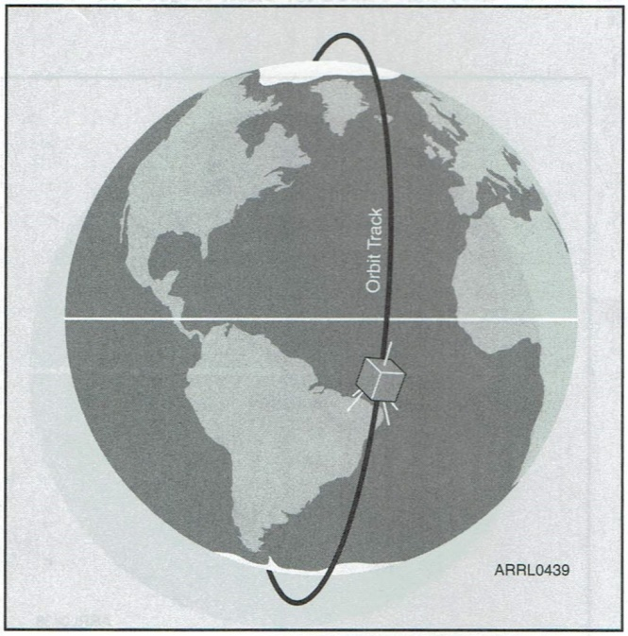

Figure 2.3 - A *dawn-to dusk* orbit is a variation on the sun-synchronous model except that the satellite spends most of its time in sunlight and relatively little time in eclips.

Figu re 2.2 - A *sun-synchronous* orbit takes the satellite over the north and south poles. A satellite in this orbit allows every station in the world to enjoy at least one high-elevation pass per day

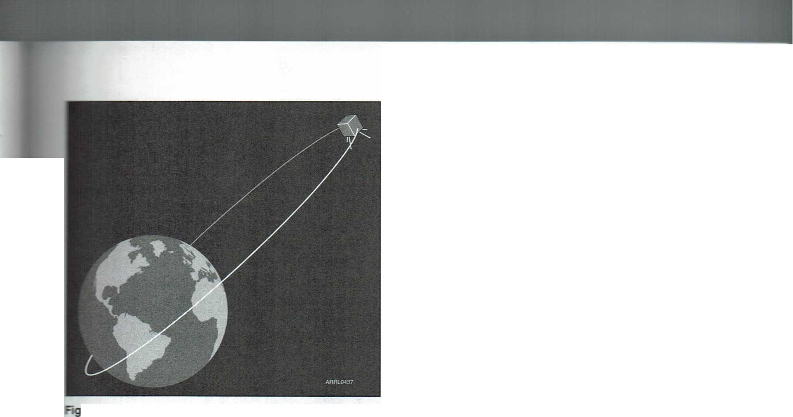

**Figure 2.4 -The *Molniya* orbit is an elliptical orbit that carries the satellite far into space at its greatest distance from Earth (apogee). To observers on the ground, the satellite at apogee appears to hover for hours at a time before it plunges earthward and (often) sweeps within 1000 km at its closest approach (perigee).**

Shuttle orbits were usually inclined at low angles and hams living in the northern US rarely enjoyed passes that brought the shuttle to a decent elevation above their local horizon.

A sun-synchronous orbit takes the satellite over the north and south poles. See Figure 2.2. There are two advantages to a sun­synchronous orbit: (1) the satellite is available at approximately the same time of day, every day and (2) everyone, no matter where they are, will enjoy at least one high-altitude pass per day. OSCAR 51 is a good example of a satellite that travels in a sun­synchronous orbit.

A dawn-to-dusk orbit is a variation on the sun­synchronous model except that the satellite spends most of its time in sunlight and relatively little time in eclipse. OSCAR 27 travels in a dawn-to-dusk orbit.

The *Molniya* orbit (Figure 2.4) was pioneered by the former Soviet Union. It is an elliptical orbit that carries the satellite far into space at its greatest distance from Earth (apogee). To observers on the ground, the satellite at apogee appears to hover for hours at a time before it plunges earthward and sweeps to (sometimes) within 1000 km or so of the Earth at its closest approach (perigee). One great advantage of the Molniya orbit is that the satellite is capable of “seeing” an entire hemisphere of the planet while at apogee. Hams can use a Molniya satellite to enjoy long, leisurely conversations spanning thousands of kilometers here on Earth. Another great advantage of the Molniya orbit is that a single satellite can give most hams around the world such “leisurely access” to it at least *part* of the time. By contrast, it takes three geostationary (and interlinked) satellites to provide continuous worldwide coverage. When this book was being written, there were no active Molniya hamsats in orbit. However, that may change within a few years.

Satellite Footprints

Speaking of how much of our planet a satellite sees, it is important to understand the concept of the satellite’s *footprint.* A satellite footprint can be loosely defined as the area on the Earth ’s surface that is “illuminated” by the satellite’s antenna systems at any given time. Another way to think of a footprint is to regard it as the zone within which stations can communicate with each other through the satellite.

Unless the satellite in question is geostationary, footprints are constantly moving. Their sizes can vary considerably, depending on the altitude of the satellite. The footprint of the low-orbiting International Space Station is about 600 km in diameter. In contrast, the higher orbiting OSCAR 52 has a footprint that is nearly 1500 km across. See the example of a satellite footprint in Figure 2.5. The amount of time you have available to communicate depends on how long your station remains within the footprint. This time can be measured in minutes, or in the case of a satellite in a Molniya orbit, hours.

It is worthwhile to note that the size and even the shape of a footprint can also vary according to the type of antenna the satellite is using. A highly directional antenna with a narrow beamwidth will create a small footprint even though the satellite is traveling in a high-altitude orbit. This usually isn’t an issue for amateur satellites, however.

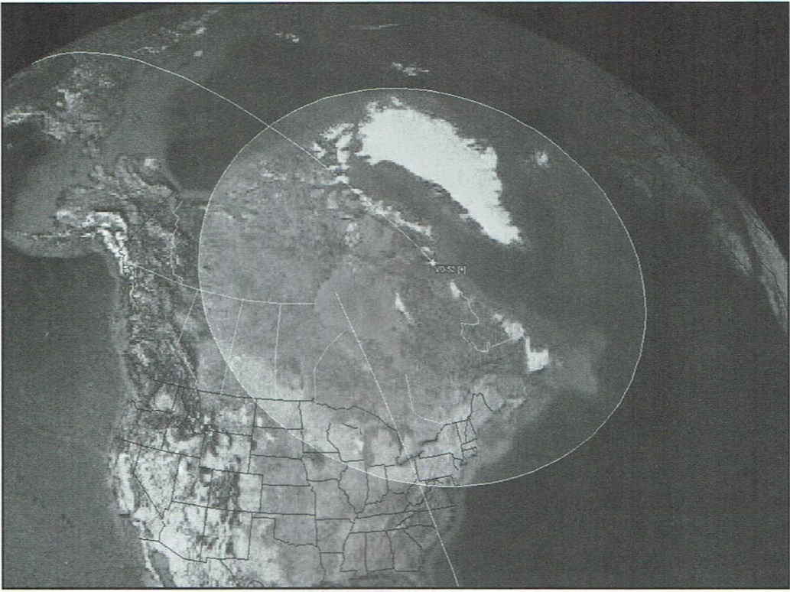

Figure 2.5 This image shows the circular footprint of OSCAR 52 as depicted by *Nova* satellite-tracki ng software. The footprint indicates the area of the Earth that is visible to the satellite at any given time.

### Understanding Your Place in the World

Before you can track an amateur satellite and communicate with it, you must first determine your own location with reasonable accuracy and understand your orientation to the expected path of the satellite.

Determining your location on the globe in terms of latitude and longitude coordinates is much easier today 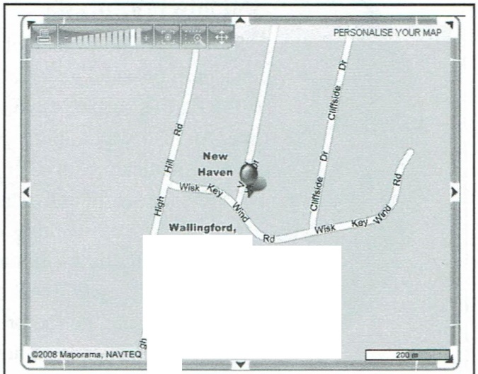than it used be. If you own a Global Positioning System (GPS) receiver, you can use it to determine your coordinates almost instantly. You simply take the receiver outdoors (or hold it up to a window), wait for it to obtain enough signals to determine your position, and write down the resulting latitude and longitude.

If you don’t own a GPS receiver, the Internet is your next best option. There are a number of mapping Web sites where you can enter your street address and see a map that includes your latitude and longitude.

For example, there is Maporama at [www.maporama. com.](http://www.maporama.com/) Simply enter your address in the “Maps” section and click the “go” arrow button. A map of your location will appear along with the latitude and longitude coordinates listed below the map. See Figure 2.6.

Figure 2.6 -Maporama at [www.maporama.com](http://www.maporama.com/) will

coordinates listed below the map. See tu rn any postal address into a map with latitude and

匂.，

que 刷

l

How precise do you need to be? If you plan on using movable directional “beam” antennas for your satellite station, the more precision the better. These antennas create more focused (and therefore more narrow) transmitting and receiving signal pattern s, so you want to be reasonably sure they are pointing in the proper direction. Your satellite tracking software will determine this direction for you, but its ability to give you accurate aiming information is highly dependent on it “knowing ” where you are located in the first place.

On the other hand, if you are using omnidirectional antennas that create broad signal patterns, or directional antennas that don’t move, the need for precision is less critical. In fact, the latitude and longitude of the nearest city will suffice. You can get this information from the US Geological Survey Web site at [www.usgs.gov.](http://www.usgs.gov/) Look for the link to the Geographic Names Information System.

Figure 2.7 -Azimuth is the direction , in degrees referenced to true north , that an antenna must

be pointed to receive a satellite signal. Imagine your station in the center of a giant compass circle that is divided i n degr関 increments from 0 to 360. North is O。（actually, it is also 360°),

east is 90。，south is 180。and west is 270。．

#### Azimuth and Elevation

In addition to pinpointing your station location, there is the additional matter of your orientation (or your antenna orientation) to the satellites as they pass overhead. Your satellite tracking software will display a satellite’s position in terms of azimuth and elevation.

Azimuth is the direction, in degrees referenced to true north，that an antenna must be pointed to receive a satellite signal. See Figure 2.7 and imagine your station in the center of a giant compass circle that is divided in degree increments from 0 to 360. North is 0°（actually, it is also 360°), east is 90°，south is 180° and west is 270°. If your tracking software indicates that you need to point your antenna to an azimuth of 135°，you ’re going to point it southeast.

Let’s take a look at a more detailed example. Once again, your station in Figure 2.8 is in the center of the compass circle. According to your satellite tracking program, the International Space Station (ISS) is scheduled to rise above your local horizon at precisely 03:57:30 UTC. The program may describe the satellite’s azimuth path like this:

|  |  |
| --- | --- |
| *Time* | *Azimuth (degrees)* |
| 03:57 | 307 |
| 03:58 | 350 |
| 03:59 | 0 |
| 04:00 | 11 |
| 04:01 | 20 |
| 04:02 | 30 |

When you plot these azimuth points on the circle in Figure 2.8, you can quickly see the horizontal path the satellite is going to take. The bird is going to rise in your northwestern sky and quickly move toward the east, finally dipping below your horizon at about 30°. If you have rotating antennas, you can now see that they’ll need to be pointing northwest at the beginning of the satellite’s path (or “pass” as it is sometimes called) across your section of sky, and then track around the circle from 307°，to 0° and so on until they are pointing to 30° when the satellite disappears.

Figure 2.9 -Elevation is simply the angle, i n degrees, between you r station and the satellite, referenced to the Earth’s surface.

Let’s add another dimension to our satellite track-elevation. Elevation is simply the angle, in degrees, between your station and the satellite, referenced to the Earth’s surface. See Figure 2.9. The elevation angle begins at 0° with the satellite at the horizon and increases to 90° when the satellite is directly overhead. Elevation is every bit as critical as azimuth if you are using directional antennas. Not only do your antennas need to be pointed at the satellite as it appears to move in the azimuth plane, they must also tilt up and down to track the satellite as it appears to move in the vertical plane.

Many amateur satellite stations use devices known as az/el (azimuth/elevation) rotators to move their antennas in both planes as the satellite streaks across the sky. However, az/el rotators are not strictly necessary to enjoy satellite operating. A well-designed omnidirectional antenna system can offer acceptable performance even though it doesn’t move to track the satellite. You can even use directional antennas that are fixed at about 45° elevation and only turn horizontally using a conventional antenna rotator. We'll discuss station antennas in more detail later in this book.

Even if you are not using directional antennas, knowing a satellite’s elevation track is important for another reason . Unless you live in Kansas or a similarly flat location, chances are you do not have a clear view to the horizon in every direction . Maybe there is a mountain, hill or building blocking the way. If you are trying to receive a microwave signal from a satellite, the RF absorption properties of trees can present serious obstacles, too. The elevations of these objects represent your true radio horizons in whichever direction they may lie (Figure 2.10). If you have a ridge to the north with an elevation of 25° above the horizon as viewed from your station, your northern radio horizon begins at 25° elevation. You can’t communicate with a satellite in your northern sky until it rises above 25°, so you’ll have to take that fact into account when you view the information provided by your satellite tracking software. Your software may tell you that the AOS (Acquisition Of Signal) time is 0200 UTC as the satellite rises in the north, but you won ’t be able to receive the bird until it reaches 25°.

The man who ex­ plained why sound waves (and radio waves) change as an object speeds toward us, then away: Chris­ tian Doppler.

Usually ... and particularly for satellites in low Earth orbits ... as the satellite’s elevation angle increases, its distance from you decreases. This is a good thing since the closer the satellite，the stronger the radio signal. With that idea in mind, the higher the elevation of a satellite pass, the better, right? Well … yes and no. Remember that satellites are moving at high speeds relative to your position. As they move closer to you (move higher in elevation), the *Doppler Effect* increasingly comes into play.

*The Doppler Effect*

The Doppler Effect, named after scientist Christian Doppler, is the change in frequency and wavelength of a wave (radio waves, in this case) as perceived by an observer moving relative to the source of the waves. See Figure 2.11. Thanks to the Doppler Effect, as a satellite moves toward your location, its signal will appear to *increase* in frequency; as it moves away from you, its signal will *decrease* in frequency.

It is important to realize that the frequency of the signal that the satellite transmits *does not actually change,* regardless of what is happening at your station. To understand this, consider the following baseball analogy illustrated in Figure 2.12. A baseball pitcher throws one ball every second and the ball takes one second to travel the distance between the pitcher’s mound and home plate. If the pitcher is stationary, the catcher will receive one ball every second. that’s because the velocity of the ball and the distance between the pitcher and the catcher remain unchanged. So far, so good. This is 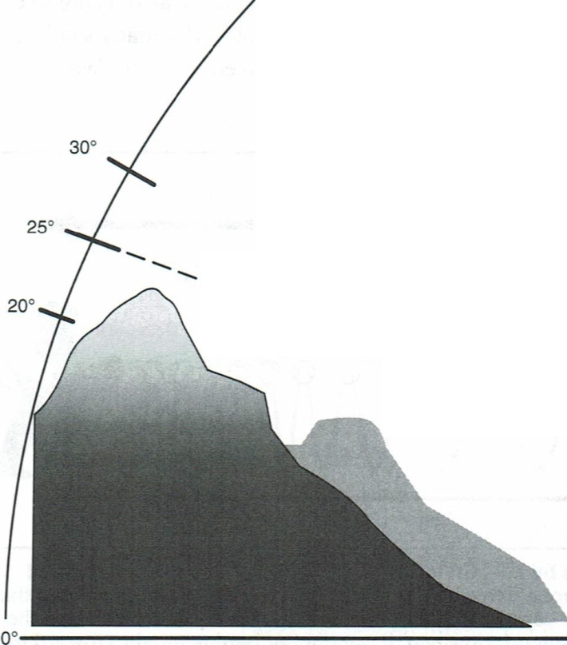exactly the condition present when a satellite is geostationary.

However, if the pitcher begins moving toward the catcher, the time it takes the ball to travel between the pitcher and the catcher *decreases.* From the catcher’s point of view, the pitcher may still be tossing balls at a rate of one per second, but the balls are taking less than one second to reach him.

If you imagine each ball representing the crest of a wave and the wavelength being the distance between one ball and another, the wavelength is decreasing as the pitcher moves toward the catcher. Since a shorter wavelength translates to a higher frequency, the frequency appears to increase. Conversely, as the wavelength increases (as the satellite moves away), the frequency decreases.

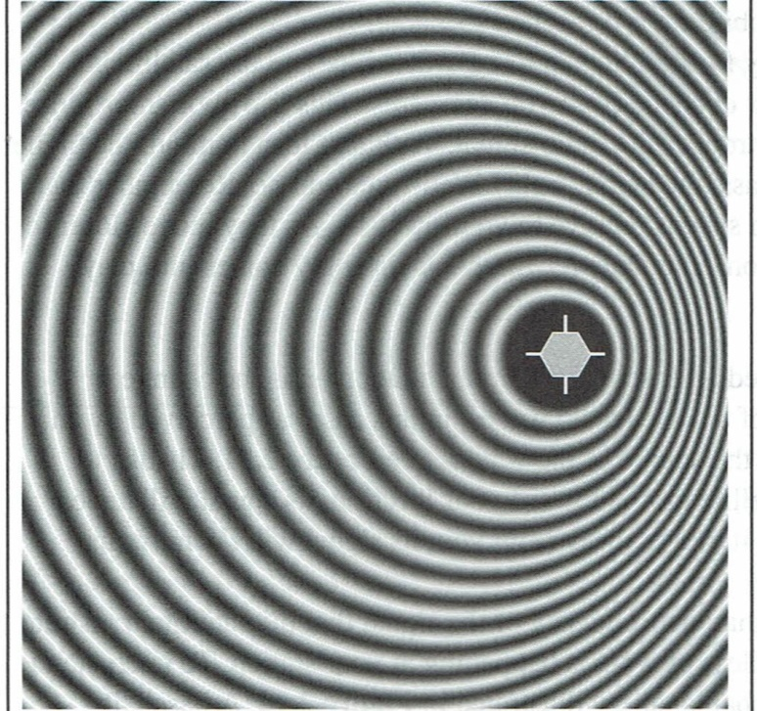You probably experience the Doppler Effect almost every day. When a fire truck approaches at high speed on a nearby freeway, you hear its siren blaring at a higher pitch, shifting downward as the truck passes and speeds off into the distance. The same thing happens with satellites, except the frequency change is applied to radio waves.

Figure 2.10 Unless you have a clear shot to the horizon (elevation O。），your radio horizon is dictated by the maximum elevation of any obstacles between you and the satellite.

At a practical level, a high elevation satellite pass can be problematic because the frequency change caused by the Doppler Effect can be considerable. this means that you 'll need to constantly change your transceiver frequency to compensate. This can be quite a juggling act when you’re also trying to carry on a conversation and move your antennas at the same time. That’s why many satellite operators rely on computers to control their antennas or transceivers, or both. We’ll discuss the operational aspects of coping with Doppler in a later chapter. For now, suffice it to say that while high elevation passes are best for signal strength，they present their own challenges thanks to the Doppler Effect.

Figure 2.11 -You can think of the Doppler Effect as being caused by radio waves “crowdi ng u p”as a satellite moves

toward you r location. As a result, its signal will appear to *increase* i n frequency as it moves toward you; as it moves away from you, its signal will *decrease* i n frequency.

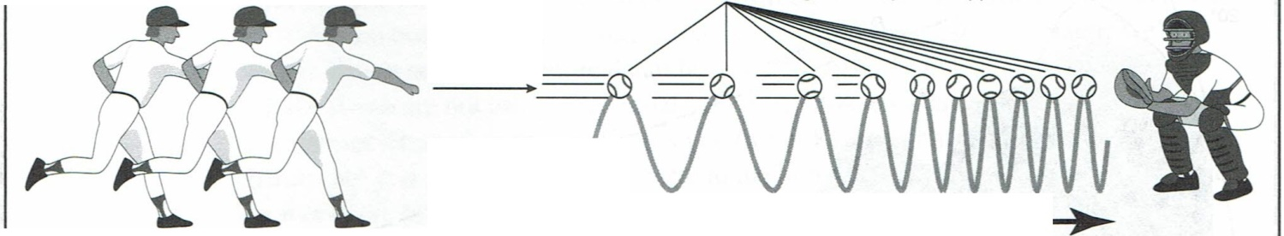 

Figure 2.12 One way to u nderstand the Doppler E行ect is by imagining a baseball pitcher who throws one ball every second. The ball takes one second to travel the distance between the pitcher’s mound and home plate. If the pitcher is stationary, the catcher will receive one ball every second. That’s because the *velocity of the ball and the*

*distance between the pitcher and the catcher remai n u nchanged. However, if the pitcher begi ns moving toward the catcher, the time it takes the ball to travel between the pitcher and the catcher decreases. If you imagine each ball representi ng the crest of a wave and the wavelength being the distance between one ba and another, the wave- length is decreasing as the pitcher moves toward the catche仁* Since a shorter wavelength translates to a higher frequency, the frequency appears to increase. Conversely, as the wavelength increases, the f req uency decreases.

#### Azimuth and Elevation Combined

Let’s combine azimuth and elevation for a truly realistic satellite track, using our previous example with the Interτ1ational Space Station. We'll add the station’s downlink frequency so we can see the Doppler Effect in action.

|  |  |  |  |
| --- | --- | --- | --- |
| *Time* | *Azimuth (degrees)* | *Elevation*  *(degrees*。*)* | *Frequency*  *(MHz)* |
| 03:57 | 307 |  | 145.804 |
| 03:58 | 350 | 10 | 145.803 |
| 03:59 |  | 18 | 145.800 |
| 04:00 | 11 | 9 | 145.798 |
| 04:01 | 20 | 5 | 145.797 |
| 04:02 | 30 | 0 | 145.795 |

In this example, the International Space Station rises to an elevation of 18° at 03:59 UTC before sinking back down to the horizon at 04:02 UTC. This is considered a low­ elevation pass. If you have objects in your northern sky that rise above 18° elevation, you won’t be able to communicate with the space station during this pass. The space station is transmitting at 145.800 MHz, but you’ll notice that the frequency change caused by the Doppler Effect is minimal because the distance between you and the space station doesn’t change dramatically. Remember: It is the relative motion between you and the satellite that increases the effect. Less relative motion means less Doppler.

Now we’11 modify our example, making it a high-elevation pass.

|  |  |  |  |
| --- | --- | --- | --- |
|  | *Azimuth* | *Elevation* | *Frequency* |
| *Time* | *(degrees)* | *(degrees*。*)* | *(MHz)* |
| 03:57  03:58 | 307  35  0 | 10 | 145.810  145.808 |
| 03:59  25 145.806  04:00 11 40 145.804  04:01 20 65 145.802  04:02 30 80 145.800  04:03 36 60 145.798  04:04 41 45 145.796  04:05 50 29 145.794  04:06 55 1。5 145.792  04:07 59  145.790 |  |  |  |

This pass of the ISS is also plotted graphically in Figure 2.13. In this illustration, we combine the azimuth and elevation, creating a “radar screen” display with your station in the center.

There are several interesting things to note in this example. Did you notice that this high-elevation pass (topping out at 80° at 04:02 UTC) had a longer overall duration than the previous low-elevation pass? The low-elevation pass lasted only 5 minutes; this pass was a full 10 minutes in length. Obviously, when an object is tracking to a high elevation in the sky (almost directly overhead in this example), it is in view for a longer period.

Did you also notice what the Doppler Effect did to the space station’s downlink signal frequency?

It started out at 145.810 MHz, shifted down to 145.800 MHz at maximum elevation, and then continued downward until it reached 145.790 MHz as the station slipped below the horizon . That's a 20-kHz frequency shift throughout the pass!

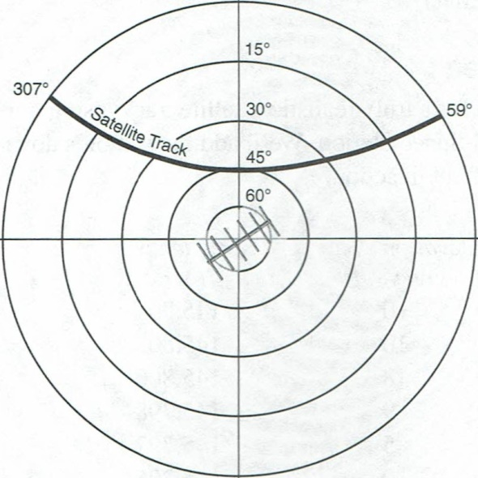

Figu re 2.13 I n this illustration, we combine the azimuth and elevation , creating a “radar screen”

display of a satellite pass with your station i n the center. The concentric rings represent elevation; the outer ring represents both zero degrees of elevation as well as azimuth.

Satellite Orbits and Tracking

Satellite Tracking Software

You'll find many satellite software programs have been written for *Windows M ac* and *Linux* operating systems. Several popular applications are listed in Table 2.1. When computers were first employed to track amateur satellites, they provided only the most basic, essential information: when will the satellite be available (AOS, acquisition of signal), how high will the satellite rise in the sky and when the satellite is due to set below your horizon (LOS, loss of signal). Today we tend to ask a great deal more of our tracking program s. Modern applications still provide the basic information, but they usually offer many more features such as:

★ The spacecraft’s operating schedule, including which traponders and beacon s are on.

★ Predicted frequency offset (Doppler shift) on the link frequencies.

★ The orientation of the spacecraft’s antennas with respect to your ground station and the distance between your ground station and the

・

ich regions of the Earth have access to 白e spacecraft ；出at is, who’s in QSO range?

★ Whether the satellite is in sunlight or being eclipsed by the Earth. Some spacecraft only operate when in sunlight.

★ When the next opportunity to cover a selected terresriial path (mutual window) will occur.

「ヨ

★ Changing data can often be updated at various intervals such as once per minute . . .or even once per second.

A number of applications do even more. Some will control antenna rotators, automatically keeping directional antennas aimed at the target satellite. Other applications will also control the radio to automatically compensate for frequency changes caused by Doppler shifting.

…

Table 2.1

A Sampling of Satellite Tracking Software

|  |  |  |  |  |
| --- | --- | --- | --- | --- |
| Name | Source | *Operating*  System | *Radio* Control? | Antenna *Control?* |
| Nova | [www.amsat.org](http://www.amsat.org) (store) | Windows | No | Yes |
| SCRAP | [www.amsat.org](http://www.amsat.org) (store) | Windows | No | Yes |
| SatPC32 | [www.amsat.org](http://www.amsat.org) (store) | Windows | Yes | Yes |
| SatScape | [www.satscape.eo.u](http://www.satscape.eo.u) k/classic.html | Windows | Yes | Yes |
| MacDopple | www.dogparkso代ware.com/MacDoppler.html | Mac OS | Yes | Yes |
| Ham Radio Deluxe | hrd.ham-radio.ch/ | Windows | Yes | No |
| Predict | [www.qsl.net/kd2bd/predict.html](http://www.qsl.net/kd2bd/predict.html) | Linux | No | Yes |
| WinOrbi | [www.sat-net.com/wi](http://www.sat-net.com/wi) norbit/ | Windows | No | No |

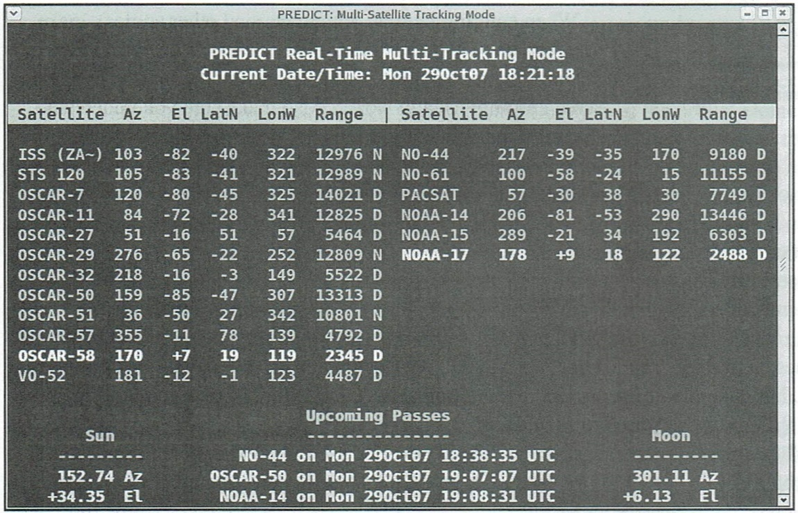

Adding additional spacecraft to the scenario suggests more questions: which satellites are currently in range, how long will each be accessible, will any new spacecraft be corning into range in the near future and so on. Obviously there is a great deal of information of potential interest. Programmers developing tracking software often find that the real challenge is not solving the underlying physics problems, but deciding what information to include and how to present it in a useful format. This is especially true since users have different interests, levels of expertise and needs. Some prefer to see the information in a graphical format, such as a map showing real-time positions for all satellites of interest. Others may prefer tabular data such as a listing of the times a particular spacecraft will be in range over the next several days.

There are also several Internet sites where you can do your tracking online. This eliminates all the hassles associated with acquiring and installing software. The currently available online tracking sites are not as powerful or flexible as the software you can install on your PC, however. One interesting site of this type is maintained by AMSAT­ NA and you'll find it at [www.amsat.org/amsat-new/tools/predict/.](http://www.amsat.org/amsat-new/tools/predict/)

#### Getting Started With Software

There are so many different types of satellites software, and they change so frequently, it would be foolhardy to attempt to give you detailed operational descriptions in any book. The book would be obsolete a month after it came off the press!

Even so, there are a number of aspects of satellite-tracking software that rarely change.

For example, we spent some time discussing how to determine your location with sufficient accuracy to be useful for satellite tracking. The next step is to get that information into your chosen program.

Most programs will ask you to enter your station location as part of the initial setup process. Some applications use the term “observer” to mean “station location，” but the terms are synonymous for the sake of our discussion. Sophisticated programs will go as far as to provide you with a list of cities that you can select to quickly enter your location. (Yes，the location of a nearby city is adequate for most applications.) Other programs will ask you to enter your latitude and longitude coordinates manually.

When entering latitude, longitude (and other angles), make sure you know whether the computer expects degree-minute or decimal-degree notation. Following the notation used by the on­ screen prompt usually works. Also make sure you understand the units and sign conventions being used. For example, longitudes may be specified in negative number for locations west of Greenwich (0。longitude). Latitudes in the southern hemisphere may also require a minus sign. Fractional parts of a degree will have very little effect on tracking data so in most cases you can just ignore it.

腸

Dates can also cause considerable trouble. Does the day or month appear first? Can November be abbreviated Nov or must you enter 11? The number is almost always required . Must you write 2010 or will 10 suffice? Should the parts be separated by colons, dashes or slashes? The list goes on and on. Once again, the prompt is your most important clue. For example, if the prompt reads “Enter date (DD:MM:YY ）” and you want to enter Feb. 9. 1010 follow the format of the prompt as precisely as possible and write 09:02: 10.

When entering numbers, commas should never be used. For example, if a semi-major axis of 20.243.51 km must be entered, type 20243.51 with the comma and units omitted. It takes a little time to get used to the quirks of each software package, but you 'll soon find yourself responding automatically.

Once you have your coordinates entered, you’re still not quite done. The software now “knows” its location, but it doesn’t know the locations of the satellites you wish to track. The only way the software can calculate the positions of satellites is if it has a recent set of *orbital elements.*

#### **Orbital Elements**

Orbital elements are a set of six numbers that completely describe the orbit of a satellite at a specific time. Although scientists may occasionally use different groups of six quantities, radio amateurs nearly always use the six known as Keplerian Orbital Elements or simply *Keps.* (Kepler, you may recall, discovered some interesting things about planetary motion back in the 17th century!)

These orbital elements are derived from very precise observations of each satellite’s orbital motion. Using precision radar and highly sensitive optical observation techniques, the North American Aerospace Defense Command (NORAD) keeps a very accurate catalog of almost everything in Earth orbit. Periodically, they issue the unclassified portions of this information to the National Aeronautics and Space Administration (NASA) for release to the general public. The information is listed by individual catalog number of each satellite and contains numeric data that describes, in a mathematical way, how NORAD observed the satellite moving around the Earth at a very precise location in space at a very precise moment in the past.

Without getting into the complex details of orbital mechanics (or Kepler’s laws!) suffice it to say that your software simply uses the orbital element information NASA publishes that describe where a particular satellite was “then” to solve the orbital math and make a prediction (either graphically or in tabular format) of where that satellite ought to be “now". The “now” part of the prediction is based on the local time and station location information you’ve also been asked to load into your software.

Orbital elements are frequently distributed with additional numerical data (which may or may not be used by a software tracking program) and are commonly available in two forms (see Tables 2.2 and 2-3).

Let’s use the easier-to-understand AMSAT format to break down the meaning, line by line.

The first two entries identify the spacecraft. The first line is an informal *satellite name.* The second entry，*Catalog Number,* is a formal ID assigned by NASA.

The next entry, *Epoch Time,* specifies the time the orbital elements were computed .

The number consists of two Parts, the part to the left of the decimal point that describes the year and day, and the part to the right of the decimal point that describes the (very precise) time of day. For example, 96325 .465598 refers to 1996, day 325, time of day .465598.

The next entry, *Element Set,* is a reference used to identify the source of the information. For example, 199 indicates element set number 199 issued by AMSAT. This information is optional. The next six entriies the the six key orbital elements.

i

4置、

：1

6

1

54

守fnJι

円MM 門U》 門出 円

ee ee

dd dd

A斗

nU 『fnunHUpo nU

30

884951324I81

201000211713

*Inclination* describes the orientation of the satellite’s orbital plane with respect to the equatorial plane of the Earth. Recall from earlier in this chapter that the higher a 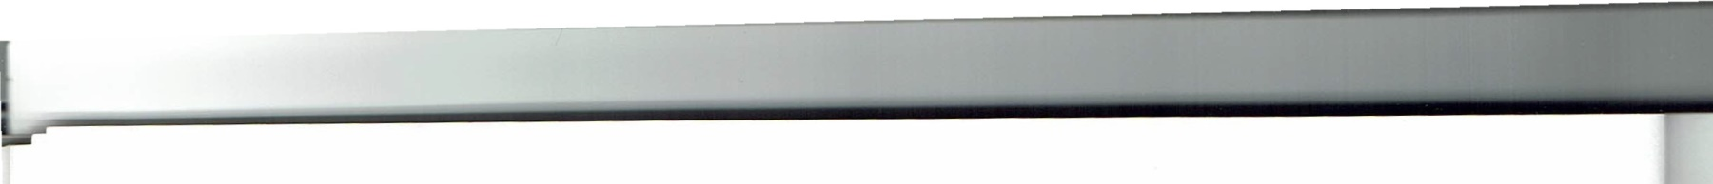satellite’s orbital inclination, the more time the bird spends away from the Equator.

*RAAN, Right Ascension of Ascending Node,* specifies the orientation of the satellite’s orbital plane with respect to fixed stars.

*Eccentricity*  refers to the shape of the orbital ellipse. You may recall our earlier discussion of elliptical Molniya orbits. These orbits are highly eccentric. The value of the eccentricity element also yields some rough information as to the shape of the orbit the satellite is following. The closer this number is to “0”, the more circular the orbit of the satellite tends to be. Conversely, an eccentricity value approaching “1”, indicates the satellite is following a more elliptically shaped (possibly a Molniya) orbital path. For example, many Molniya orbit satellites have eccentricities in the .6 to .7 range.

*Argument of Perigee* describes where the perigee of the satellite is located in the satellite orbital plane. Recall that a satellite’s perigee is its closest approach to the Earth. When the argument of perigee is between 180° and 360° the perigee will be over the Southern Hemisphere . Apogee-a satellite’s most distant point from the Earth-will therefore occur above the Northern Hemisphere.

*Mean Anomaly* locates the satellite in the orbital plane at the epoch. All programs use the astronomical convention for mean anomaly (MA) units. The mean anomaly is 0° at perigee and 180° at apogee. Values between 0° and 180° indicate that the satellite is headed up toward apogee. Values between 180° and 360° indicate that the satellite is headed down toward perigee. More about this later.

*Mean M otion* specifies the number of revolutions the satellite makes each day. This element indirectly provides information about the size of the elliptical orbit.

*Decay Rate* is a parameter used in sophisticated tracking models to take into account how the frictional drag produced by the Earth’s atmosphere affects a satellite’s orbit. It may also be referred to as rate of change of mean motion, first derivative of mean motion, or drag factor. Although decay rate is an important parameter in scientific studies of the Earth’s atmosphere and when observing satellites that are about to reenter, it has very little effect on day-to-day tracking of most Amateur Radio satellites. If your program asks for drag factor, enter the number provided. If the element set does not contain this information enter zero --- you shouldn’t discern any difference in predictions. You usually have a choice of entering this number using either decimal form or scientific notation. For example， the number -0.00000039 (decimal form) can be entered as -3.9e-7 (scientific notation）. T'he e-7 stands for 10 to the minus seventh power (or 10 exponent -7). In practical terms e-7 just means move the decimal in the preceding number 7 places to the left. If this is totally confusing, just remember that in most situations entering zero will work fine.

。－

*Epoch revolution* is just another term for the expression “Orbit Number” that we discussed earlier. The number provided here does not affect tracking data, so don’t worry if different element sets provide different numbers for the same day and time.

The *Checksum* is a number constructed by the data transmitting station and used by the receiving station to check for certain types of transmission errors in data files. It does not bear any relationship to a satellite’s orbit.

In the “old days” of satellite-tracking software you had to enter the orbital elements by hand. This was a tedious and risky process. If you entered an element number incorrectly, you would generate wildly inaccurate predictions.

Today, thankfully, most satellite-tracking programs have greatly streamlined the process. One method of entering orbital elements is to grab the latest set from the AMSAT-NA Web site at www.amnsat.org (look under “Keps” in the main menu). You can download the element set as a text file and then tell your satellite-tracking program to read the file and create the database. Another excellent site is CelesTrak at celestrak.com. Your program will probably be able to read either the AMSAT or NASA formats.



If you’re fortunate to own sophisticated tracking software such as *Nova,* and you have access to the Internet, the program will reach into cyberspace, download and process its Keps automatically. All it takes is a single click of your mouse button. Some programs can even be configured to download the latest Keps on a regular basis without any prompting from you.

*The Need for Fresh Keps*

So how often do you need to grab a set of fresh orbital elements? The answer depends on several factors including the satellite orbit, the location of the ground station, the directional patterns of the 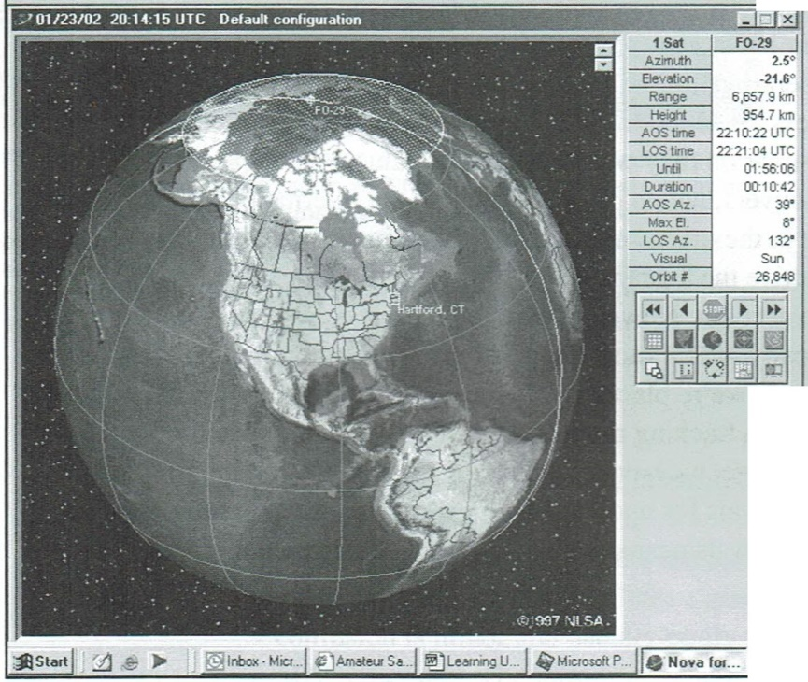ground station antennas, whether one is interested in short DX windows at AOS/ LOS, if automatic Doppler compensation is being used and so on. With all these factors affecting the situation, there can’t be a single simple answer, but looking at some relevant information and considering a number of typical situations can provide some helpful guidelines.

*Note that the age of a set of elements is* mea*sured from the epoch time, notfrom when they* ’*re received .*

The mathematical algorithms used by government agencies who distribute orbital elements are designed to provide very good prediction s for period s less than 10 days. One result is that the long term effects of small periodic and sporadic perturbations due to atmospheric drag, magnetic storms and other factors can either be over- or understated. In the early days of the OSCAR program (mid 1970s) amateurs produced their own smoothed orbital elements for LEO spacecraft that averaged-out these small perturbations. In many cases, the amateur-produced elements gave better long term results than today ’s high precision values. For example, with OSCARs 6, 7 and 8 and early RS spacecraft, orbital elements produced in the amateur community were used to generate “Orbit Calendars” that were accurate to within a couple of minutes over a 12-month period. With Phase III satellites the situation is similar. When OSCAR 13 was still operating, G3RUH would periodically produce a set of smoothed orbital elements for the command team. These elements provided excellent predictions for up to a year.

Since the elements currently distributed by AMSAT and other groups are generally from government sources (optimized for short term prediction s) our discussion will focus on them. A ground station using either a low gain beam or an omnidirectional antenna working a linear transponder on a satellite in a low altitude circular orbit, will generally find that an accurate set of orbital elements will provide good results for three to six months if the satellite orbital altitude is above 1000 km. For satellites with orbital altitudes in the range 600 to 800 km, updating every second month should be sufficient. For satellites in orbital altitudes below 600 km (such as the International Space Station [ISS]), daily updating is often required. In particular, the ISS does a lot of maneuvering so its orbit changes frequently. What’s more, because the ISS orbit is already relatively low (and it is a big orbiting object!) upper atmospheric drag has a much more pronounced effect on it than on smaller satellites at higher altitudes. Therefore, obtaining more frequent orbital element updates is always prudent when tracking the ISS. This becomes particularly true when the Space Station is doing a lot of maneuvering in conjunction with periodic Space Shuttle visits. Of course, you may find it desirable to update more frequently if you ’re using a very high gain narrow beamwidth antenna, if you ’re especially interested in mutual DX windows lasting fractions of a minute, or if you use computer software to compensate for Doppler frequency shifts.

For hamsats operating in Molniya orbits, the elements should be updated at least two or three times a year. If operation around perigee is important, however, updating every month or two may be necessary. Of course, all these values are just suggestions and the details of your particular situation may warrant different values.

Aside from orbital maneuvers, which pertain mostly to the International Space Station, the main cause for change in the orbital elements of low altitude satellites is atmospheric drag. When the Sun is inactive the average status of the atmosphere can be well predicted and drag can be taken into account. However, when the sun is active, atmospheric composition changes radically over a short period of time, making it impossible to take drag into account. As a result, we’re placed in a rather poor position. Drag effects can be accurately incorporated in a tracking model only when they’re small and relatively unimportant. When they ’re large, we have no reliable way of modeling them. When using the suggested time intervals for updating orbital elements, keep in mind that you might want to shorten the intervals near sunspot maxima and lengthen them near sunspot minima.

##### A Satellite’s “Phase”

Your software will probably be able to tell you more about a satellite than simply

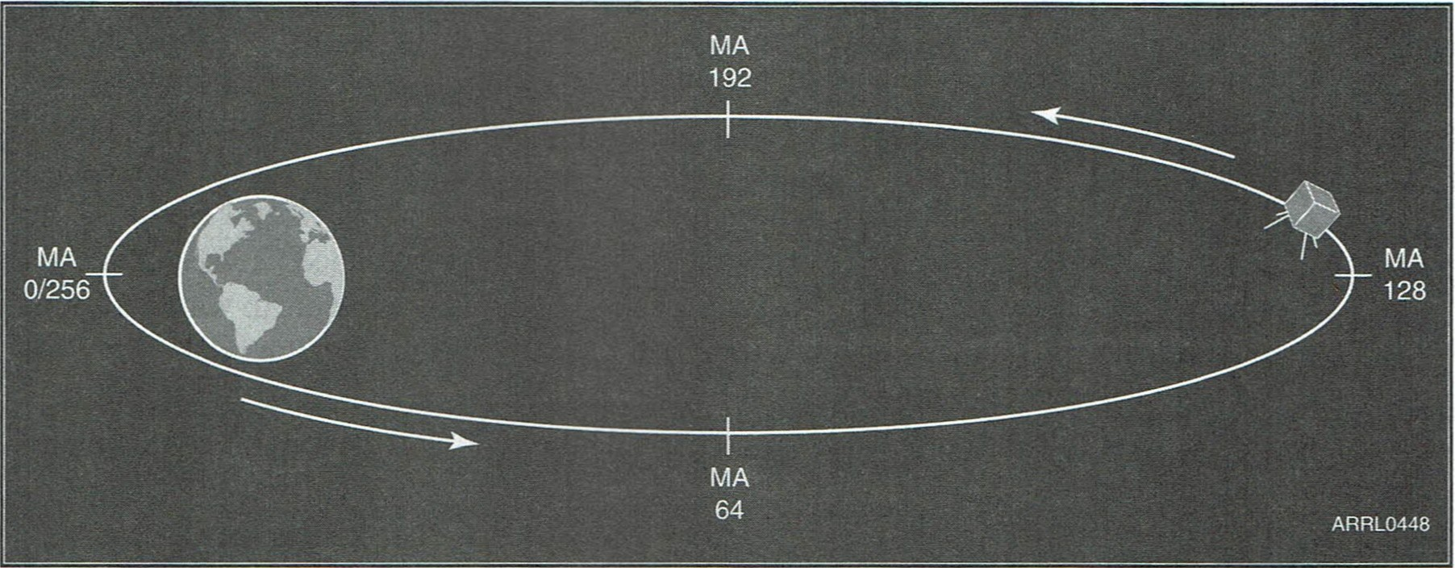

Figure 2.14 -Mean anomaly (MA) divides each orbit into 256 segments of equal time duration. Radio amateurs refer to these as “Mean Anomaly ”or “Phase”units. The duration of each segment is the sate ite’s period divided by 256. For example, a mean anomaly unit for OSCAR 13 was roughly 2.68

minutes. At MA 0 (beginning of orbit) and MA 256 (end of orbit) the satellite is at perigee (its lowest poi nt). At MA 128 (halfway through the orbit) the satellite is at apogee (or it’s highest poi nt).

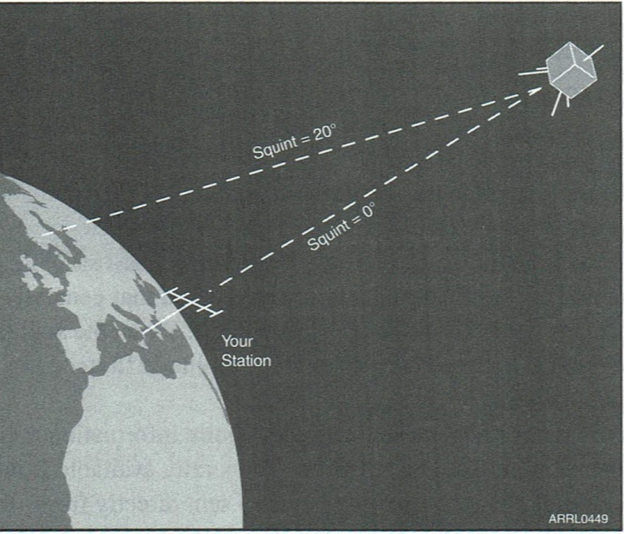

2.15 -The squint angle describes how the directive

nas on a satellite (such as Phase Ill satellites) are pointed

espect to your ground station. Squint angles can vary en 0° and 180。A. squint angle of O。means the

satellite

nas are pointed directly at you, which, in turn, means

ink performance can usually be expected. When the angle is above 20。signal levels begin to drop.

where it is located or when it will arrive. Some satellites, especially the big multi- transponder birds that travel in Molniya orbits, use operating schedules to determine which transponders and antenna are active at any given time. This “Phase” information is determined by the satellite’s mean anomal*y,* or *MA.*

This isn’t as complicated as it sounds. The expression “anomaly” is just a fancy term for *angle.* Astronomers have traditionally divided orbits into 360 mean-anomaly units, each containing an equal time segment. Because of the architecture of common microprocessors, it was much more efficient to design the computers controlling spacecraft to divide each orbit into 256 segments of equal time duration. Radio amateurs refer to these as mean anomaly or phase units. The duration of each segment is the satellite’s period divided by 256. For example, a mean anomaly unit for OSCAR 13 was roughly 2.68 minutes. At MA 0 (beginning of orbit) and MA 256 (end of orbit) the satellite is at perigee (its lowest point). At MA 128 (halfway through the orbit) the satellite is at apogee (its high point). See Figure 2.14.

Because radio amateurs and astonomers use the term mean anomaly in a slightly different way, there’s sometimes a question as to which system is being used. Any confusion is minor and usually easily resolved. Most OSCAR telemetry with real-time MA values and schedules use the 256 system. The term “phase，” and the fact that no numbers larger than 256 ever appear, are significant hints. Computer tracking programs designed for non-radio amateur audiences generally use the traditional astronomical notation. It’s easy to determine when this is the case because the mean anomaly column will contain entries between 257 and 360.

If a satellite is using an MA-based schedule, the schedule will be posted on the AMSAT-NA Web site at [www.amsat.org.](http://www.amsat.org/) (When this book was written there were no Amateur Radio satellites using MA scheduling, but this may change as currently planned satellites reach orbit.) Depending on its sophistication, your tracking software may allow you to enter this schedule. The software will then automatically tell you which operating schedule is in effect for any given time. This comes in very handy when you ’re about to sit down for an afternoon of satellite operating.

Schedules are generally modified every few months when satellite orientation is adjusted to compensate for changes in the Sun angle on the spacecraft. A typical schedule used for OSCAR 13, with its corresponding uplink (transmitting) and downlink (receiving) frequency band requirements, looked like this:

Off: from MA 0 until MA 49

Mode UN (uplink on 70 cm/downlink on 2 meters): on from MA 50 until MA 128

Mode U/S (uplink on 70 cm/downlink on 2.4 GHz): on from MA 129 until MA 159

Mode UN (uplink on 70 cm/downlink on 2 meters): on from MA 160 until MA 255

If you wanted to operate Mode U/S, you needed to be at the radio when the satellite was between MA129 and MA159 in its orbit.

*Squint Angle*

Another dilemma your software may help resolve is the squint angle. The squint angle describes how the directive antennas on a satellite (such as Phase 皿 satellites） are pointed with respect to your ground station. Squint angle can vary between 0° and 180°. A squint angle of 0° means the satellite antennas are pointed directly at you and that generally indicates that good link performance can be expected (Figure 2.15). When the squint angle is above 20° signal level begins to drop and a disruptive amplitude flutter called spin modulation on uplinks and downlinks may become apparent.

Programs that include algorithms to calculate squint angle require information about the orientation or attitude of the satellite. This information is generally available from sources that provide the basic orbital elements and on telemetry sent directly from the satellite of interest. The parameters needed are labeled Bahn latitude and Bahn longitude. They are also known as BLAT and BLON or ALAT and ALON where the prefix “A” stands for attitude.

Programs that provide squint angle information may also contain a column labeled *Predicted Signal Level.* Values are usually computed using a simple prediction model that takes into account satellite antenna pattern, squint angle and spacecraft range. For Phase III satellites the model assumes a 0 dB reference point with the satellite overhead, at apogee and pointing directly at you. At any point on the orbit the predicted level may be several dB above (+) or below （一） this reference level.

You won’t need to be concerned about squint angle for most low-Earth orbiting satellites. It only becomes a factor with the high-altitude birds since they generally use directive antennas. As with MA scheduling, you’ll want to know that the satellite’s antennas are pointing at your location before you fire up your equipment. With the right kind of software, you'll know well ahead of time.